Variables in C

A **variable** is a name of the memory location. It is used to store data. Its value can be changed, and it can be reused many times.

It is a way to represent memory location through symbol so that it can be easily identified.

Data Type

A data-type in C programming is a set of values and is determined to act on those values. C provides various types of data-types which allow the programmer to select the appropriate type for the variable to set its value.

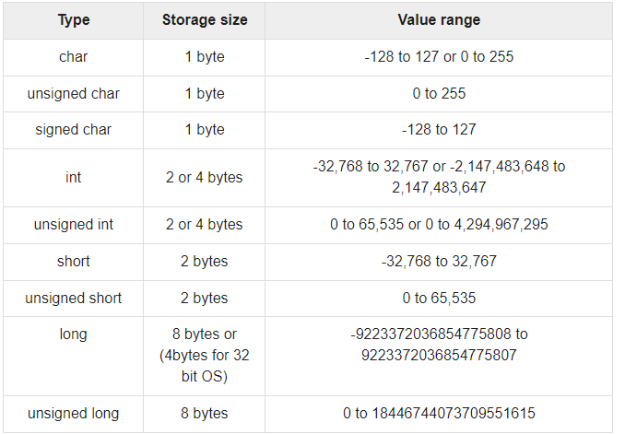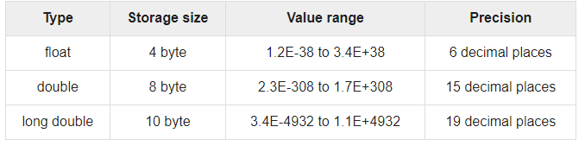

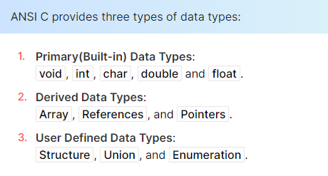

#include <stdio.h>

int main()

{

int a = 4000; // positive integer data type

float b = 5.2324; // float data type

char c = 'Z'; // char data type

long d = 41657; // long positive integer data type

long e = -21556; // long -ve integer data type

int f = -185; // -ve integer data type

short g = 130; // short +ve integer data type

short h = -130; // short -ve integer data type

double i = 4.1234567890; // double float data type

float j = -3.55; // float data type

}

-------------------------------------------------------

#include <stdio.h>

#include <limits.h>

int main()

{

printf("Storage size for int is: %d \n", sizeof(int));

printf("Storage size for char is: %d \n", sizeof(char));

return 0;

}